Assignment -4 SMS SPAM Classification

**Question-1.** Import required library

Solution:

import pandas as pd import numpy as np

import matplotlib.pyplot as plt

from sklearn.model_selection import train_test_split from sklearn.preprocessing import LabelEncoder from keras.models import Model

from keras.layersimport LSTM,Activation, Dense, Dropout, Input, Embedding from keras.optimizers import Adam fromkeras.preprocessing.textimportTokenizer

from keras.preprocessing import sequence from keras.utils import pad_sequences from keras.utils import to_categorical from keras.callbacks import EarlyStopping

**Question-2.** Read the Dataset

Solution:

**df = pd.read_csv('spam.csv',delimiter=',',encoding='latin-1')**

df.head()

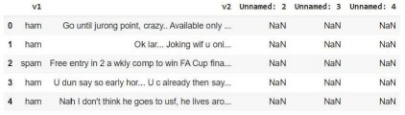

**Question-3.** Preprocessing the Dataset

Solution:

df.drop(['Unnamed: 2', 'Unnamed: 3', 'Unnamed: 4'],axis=1,inplace=True) from wordcloud import WordCloud, STOPWORDS, ImageColorGenerator

X = df.v2 Y = df.v1

le =LabelEncoder()

Y =le.fit_transform(Y) Y = Y.reshape(-1,1)

X_train,X_test,Y_train,Y_test = train_test_split(X,Y,test_size=0.25)

max_words = 1000

max_len = 150 tok =

tok.fit_on_texts(X_tr

Tokenizer(num_wordain)

s=max

_

words)

sequences = tok.texts_to_sequences(X_train) sequences_matrix = pad_sequenc

es(sequences,maxlen=max_len)

**Question-4.**Create Model

Solution:

inputs = Input(shape=[max_len])

layer = Embedding(max_words,50,input_length=max_len)(inputs) layer = LSTM(128)(layer)

layer = Dense(128)(layer) layer = Activation('relu')(layer)

layer = Dropout(0.5)(layer) layer = Dense(1)(layer)

layer = Activation('sigmoid')(layer)

model = Model(inputs=inputs,outputs=layer)

**Question-5.** Add Layers (LSTM, Dense-(Hidden Layers), Output)

Solution:

model.summary()

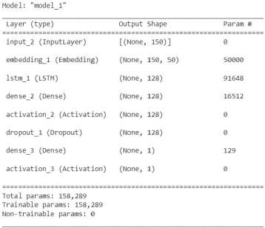

**Question-6.**Compile the Model

Solution:

model.compile(loss='binary_crossentropy',optimizer=Adam(),metrics=['accuracy'])

**Question-7.** Fit the Model

Solution:

history = model.fit(sequences_matrix,Y_train,batch_size=20,epochs=15,

validation_split=0.2)

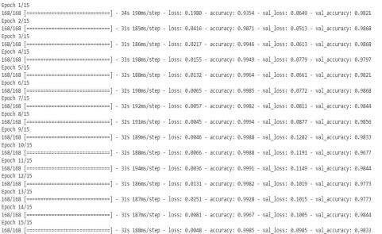

metrics = pd.DataFrame(history.history)

metrics.rename(columns ={'loss':'Training_Loss', 'accuracy':'Training_Accuracy', 'val_loss': 'Valida tion_Loss', 'val_accuracy': 'Validation_Accuracy'}, inplace = True)

def plot_graphs1(var1, var2, string): metrics[[var1, var2]].plot() plt.title('Training and Validation ' + string)

plt.xlabel ('Number of epochs') plt.ylabel(string)

plt.legend([var1, var2])

plot_graphs1('Training_Accuracy', 'Validation_Accuracy', 'Accuracy')

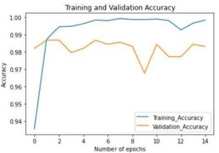

**Question-8.**Save The Model

Solution:

model.save('Spam_sms_classifier.h5')



**Question-9.** Test The Model

Solution:

test_sequences = tok.texts_to_sequences(X_test)

test_sequences_matrix = pad_sequences(test_sequences,maxlen=max_len)

accuracy1 = model.evaluate(test_sequences_matrix,Y_test)



print(' loss: {:0.4f}'.format(accuracy1[0]))

print(' Accuracy: {:0.4f}'.format(accuracy1[1]))

